Armani

Model ; Armani A5.6-II
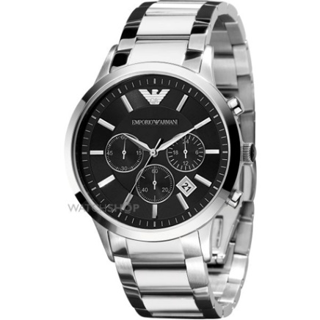 | 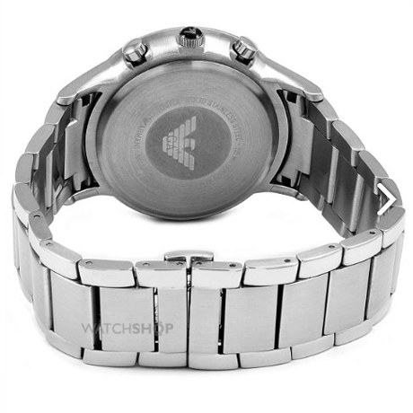 | 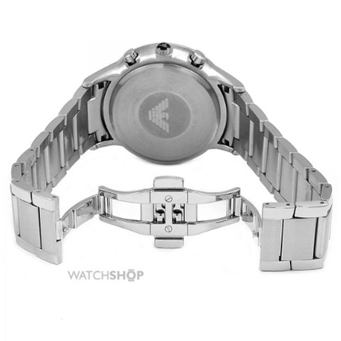

Product details

This Men's Emporio Armani watch has a stainless steel case and clear.

Material & care
- Stainless Steel
- Water Proof

Size & Fit
- Regular fit
- Sizes Available
A5.6-II
This Men's Emporio Armani watch has a stainless steel case and clear, classy looking black dial with silver baton hour markers and other elegant silver touches.

Model ; Armani A1.0 II
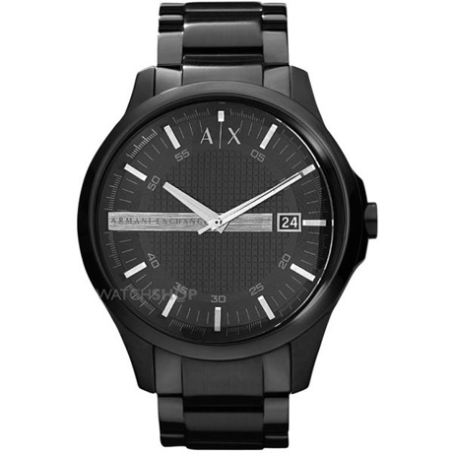 | 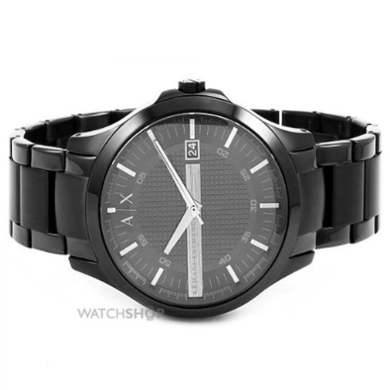 | 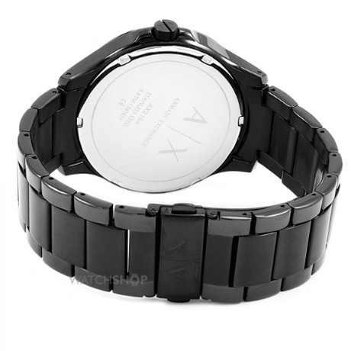

Product details

This Men's Emporio Armani watch has a stainless steel case and clear.

Material & care
- Stainless Steel
- Water Proof

Size & Fit
- Regular fit
- Sizes Available
A1.0 II
This Men's Emporio Armani watch has a stainless steel case and clear, classy looking black dial with silver baton hour markers and other elegant silver touches. Also features chronograph, date function and powered by a quality quartz movement. The watch fastens with a chunky stainless steel bracelet.

Model ; Armani A4-I
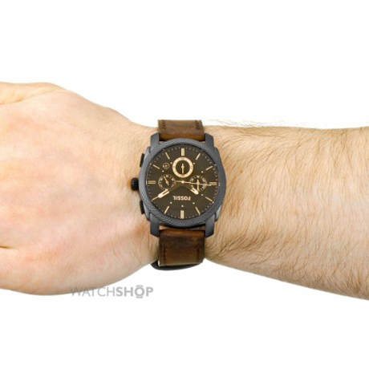 | 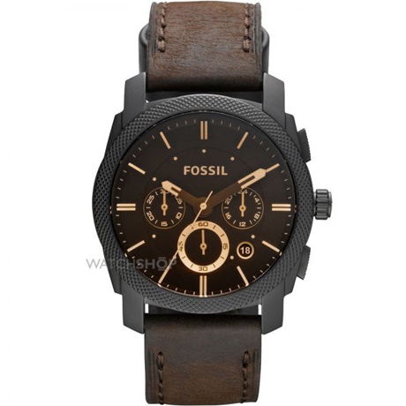 | 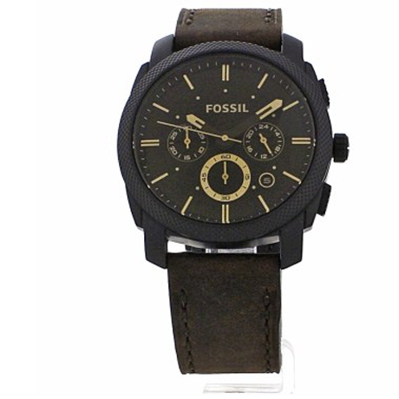

Product details

This Men's Emporio Armani watch has a stainless steel case and clear.

Material & care
- Stainless Steel
- Water Proof

Size & Fit
- Regular fit
- Sizes Available
A4-I
This Men's Emporio Armani watch has a stainless steel case and clear, classy looking black dial with silver baton hour markers and other elegant silver touches. Also features chronograph, date function and powered by a quality quartz movement. The watch fastens with a chunky stainless steel bracelet.

Model ; Armani A5-I
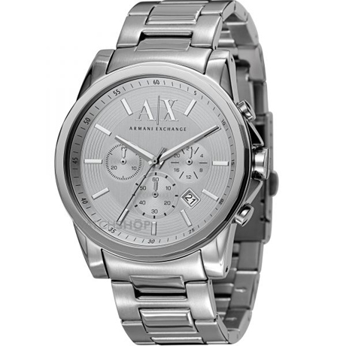 | 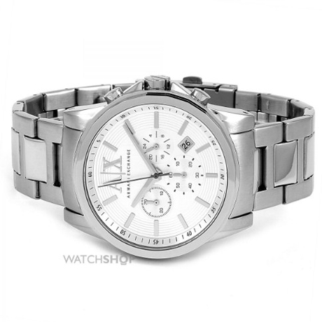 | 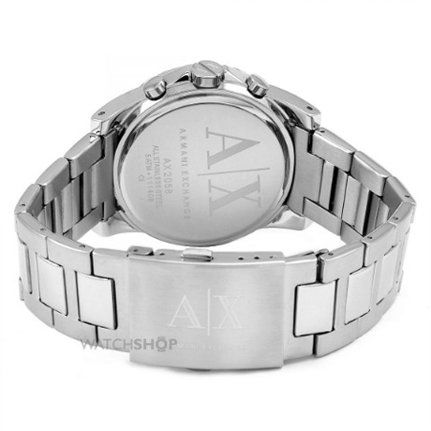

Product details

This Men's Emporio Armani watch has a stainless steel case and clear.

Material & care
- Stainless Steel
- Water Proof

Size & Fit
- Regular fit
- Sizes Available
A5-I
This Men's Emporio Armani watch has a stainless steel case and clear, classy looking black dial with silver baton hour markers and other elegant silver touches. Also features chronograph, date function and powered by a quality quartz movement. The watch fastens with a chunky stainless steel bracelet.

Model ; Armani A-gold-1
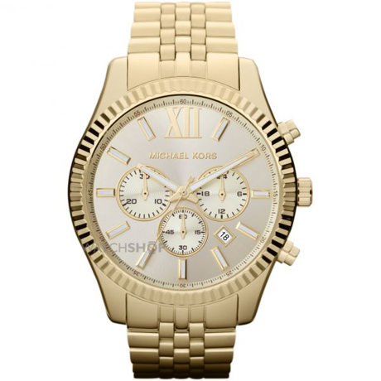 | 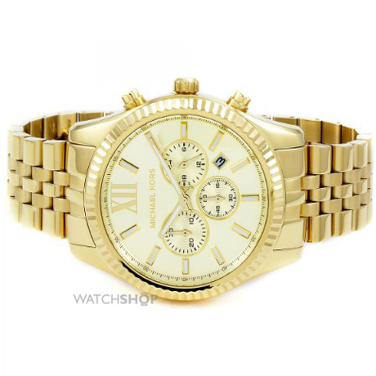 | 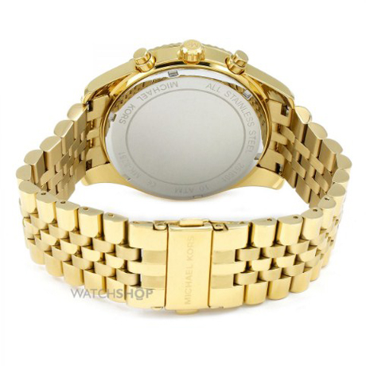

Product details

This Men's Emporio Armani watch has a stainless steel case and clear.

Material & care
- Stainless Steel
- Water Proof

Size & Fit
- Regular fit
- Sizes Available
A-gold-1
This Men's Emporio Armani watch has a stainless steel case and clear, classy looking black dial with silver baton hour markers and other elegant silver touches. Also features chronograph, date function and powered by a quality quartz movement. The watch fastens with a chunky stainless steel bracelet.

Model ; Armani A5.6-II
 |  | 

Product details

This Men's Emporio Armani watch has a stainless steel case and clear.

Material & care
- Stainless Steel
- Water Proof

Size & Fit
- Regular fit
- Sizes Available
This Men's Emporio Armani watch has a stainless steel case and clear, classy looking black dial with silver baton hour markers and other elegant silver touches. Also features chronograph, date function and powered by a quality quartz movement. The watch fastens with a chunky stainless steel bracelet.

Model ; Armani A5.6-II
 |  | 

Product details

This Men's Emporio Armani watch has a stainless steel case and clear.

Material & care
- Stainless Steel
- Water Proof

Size & Fit
- Regular fit
- Sizes Available
This Men's Emporio Armani watch has a stainless steel case and clear, classy looking black dial with silver baton hour markers and other elegant silver touches. Also features chronograph, date function and powered by a quality quartz movement. The watch fastens with a chunky stainless steel bracelet.

